# Greater and Less Than

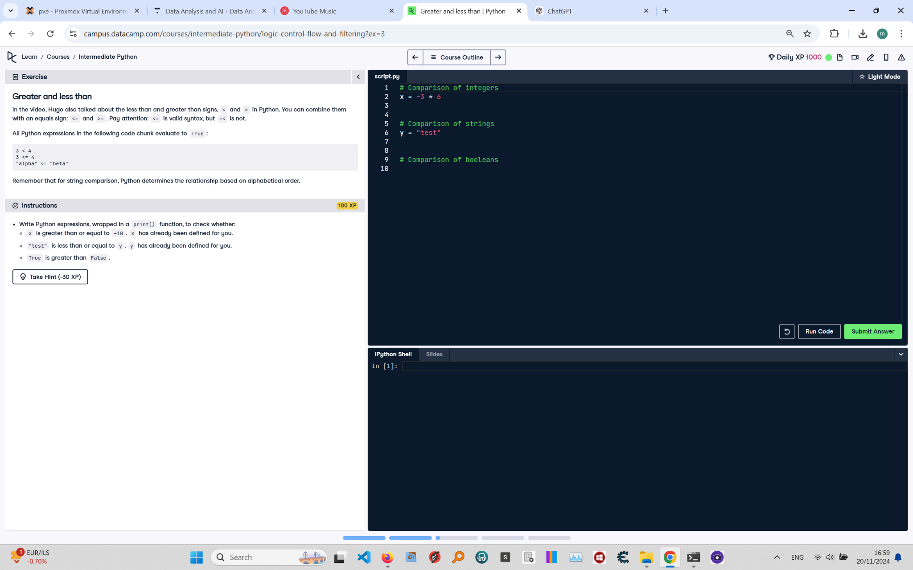

Below is the exercise on 'Greater and Less Than' from the Python course. The image includes the instructions, code, and questions to be answered.

Instructions:

Write Python expressions, wrapped in a print() function, to check whether:

1. x is greater than or equal to -10. (x has already been defined for you.)

2. 'test' is less than or equal to y. (y has already been defined for you.)

3. True is greater than False.

Solution:

# Comparison of integers  
x = -3 * 6  
print(x >= -10) # Checks if x is greater than or equal to -10  
  
# Comparison of strings  
y = "test"  
print("test" <= y) # Checks if 'test' is less than or equal to y (alphabetical order)  
  
# Comparison of booleans  
print(True > False) # True evaluates to 1, and False evaluates to 0

Explanation:

1. In the first comparison, we calculate x as -3 * 6, which is -18. Then we check if -18 >= -10. The result is False.

2. In the second comparison, we check if 'test' is less than or equal to y. Since y is also 'test', the result is True as they are equal.

3. The boolean comparison checks if True (1) is greater than False (0), which is True.